the WEALTH

of NATIONS

Fernando Alberte García Vieites

05-01-2024

**Table of Contents**

Policies and procedures……………………………………………………………………………………………………. 3

Excel task report…………………………………………………………………………………………………………………. 4

Tableau task report……………………………………………………………………………………………………………. 8

Reflective Account……………………………………………………………………………………………………………… 11

**Policies and Procedures**

When working with data it is essential to use it and store it in a manner that is ethical and ensures the data is protected from purposes that it was not provided for. This ensures that the company and the data analyst does not break the law and protects the information from misuse.

Due to this, a data analyst should be aware of different policies and procedures to ensure the data is used following the principles of UK GDPR (ICO, 2024):

* That it is used lawfully and in a fair and transparent manner.
* That it is only used for the purpose intended for.
* That only the strictly necessary information is collected for the intended purpose.
* That it is accurate and kept up to date
* That it is deleted when it is no longer necessary.
* That it is fully protected and maintained secured at all times.
* That those that control the data are responsible for processing the data accordingly.

The last principle is key for data analysts as in our role we should be accountable for any break in compliance in the way we use the data. As a result, we must:

* Read, understand and follow any company’s data procedures and policies that we must follow.
* Our role must be outlined in a contract including what is the data and the purpose for analysing it.
* Understand what the purpose of the data is being collected and what are the limitations for us to use it.
* How it should be securely stored and updated.
* How to inform of any data breaches.

Finally, according to the Central Digital and Data Office (2024), working with data must also follow:

* The Equality Act 2010 to ensure our decisions do not result in discrimination.
* The Code of Practice for Data Sharing to ensure any sharing of information between organisations comply with the law and ethic principles.
* Copyright and intellectual property regulations when dealing with databases and software.
* Code of Practice for Statistics to ensure the correct access, use and sharing of public data for research and statistical purposes.

Central Digital and Data Office (2024) “How to use the Data Ethics Framework”. <https://www.gov.uk/government/publications/data-ethics-framework/data-ethics-framework-2020>

Information Commissioner’s Office (2024) “A guide to the data protection principles”. <https://ico.org.uk/for-organisations/uk-gdpr-guidance-and-resources/data-protection-principles/a-guide-to-the-data-protection-principles/>

**Excel Task Report**

* Save protected file with password

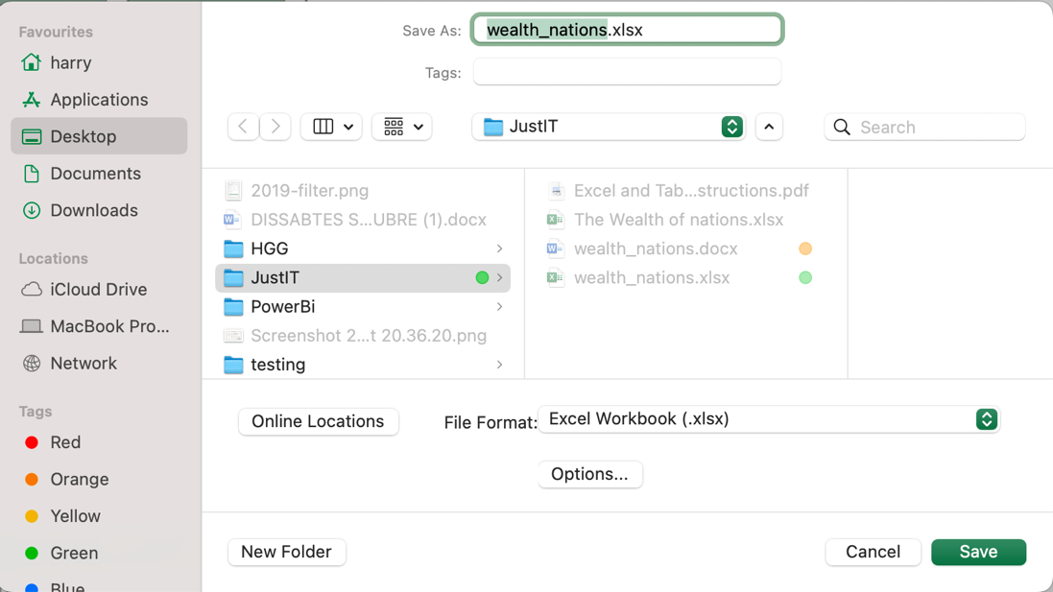

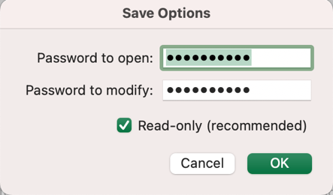

* 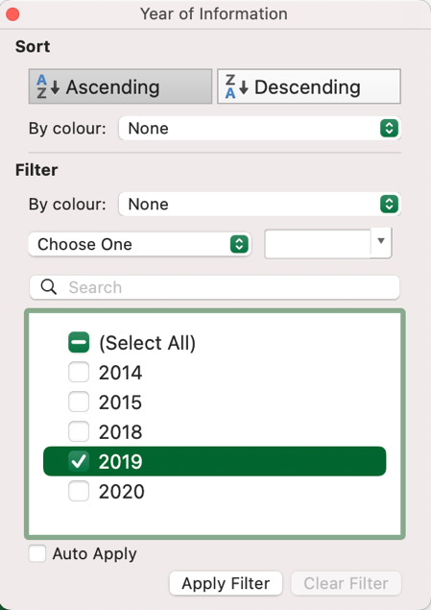Filter by 2019 year
* 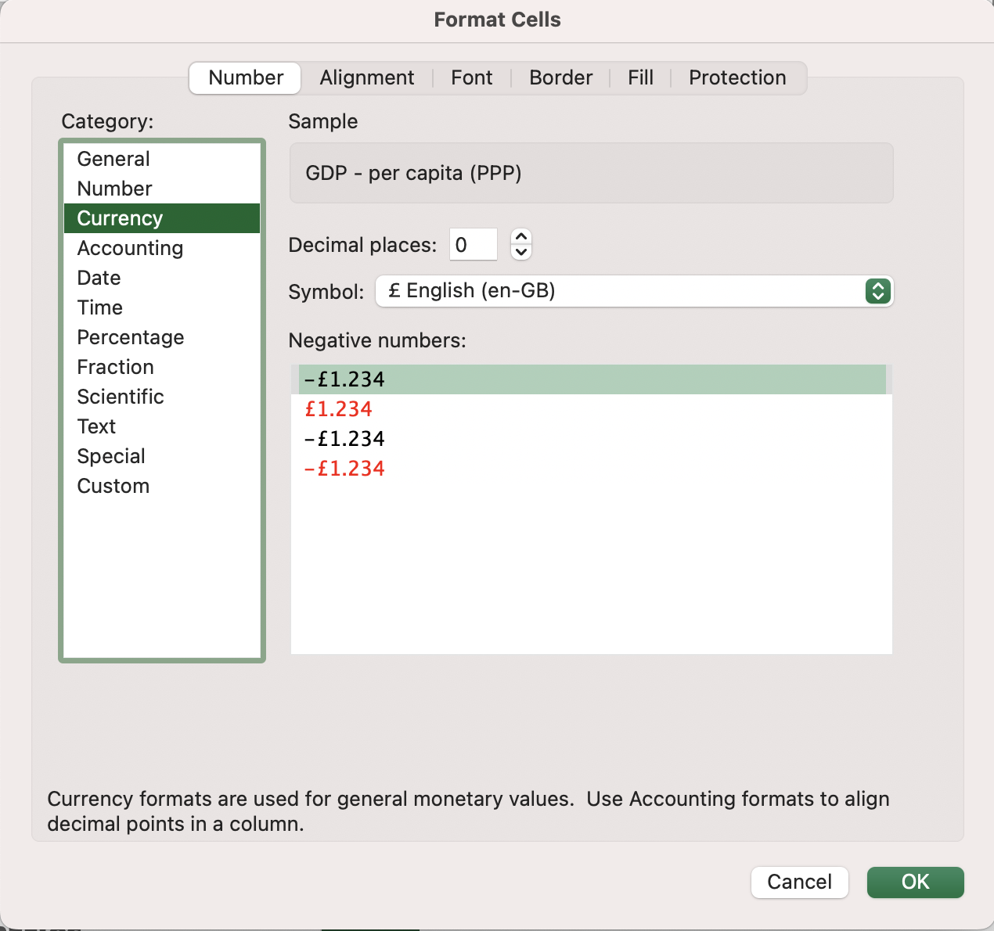Customize data to display pounds
* After selecting the data, click on data icon in the Insert tab

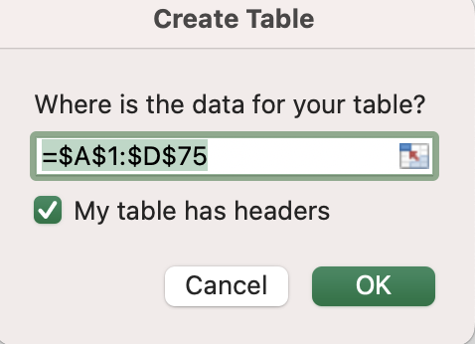

* 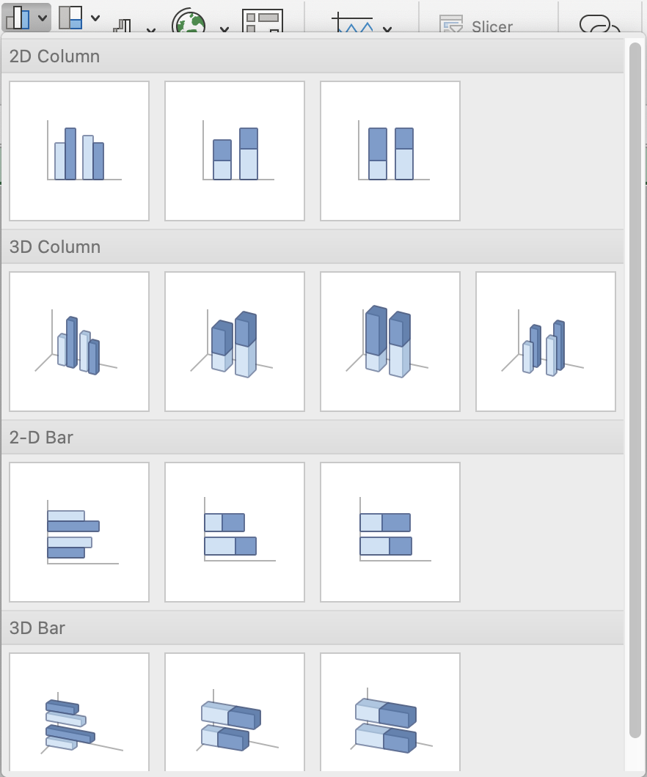After selecting the data, click on chart icon in the Insert tab
* I pasted the chart as an image to avoid update the data
* 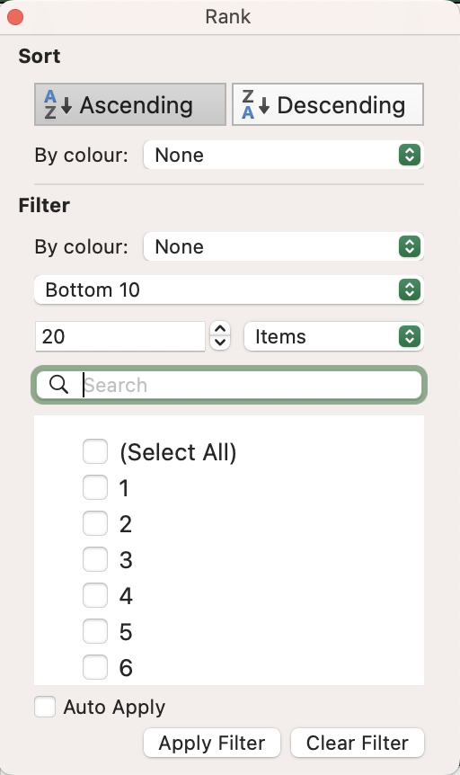Menu to filter top 20 countries.

**Tableau Task Report**

* 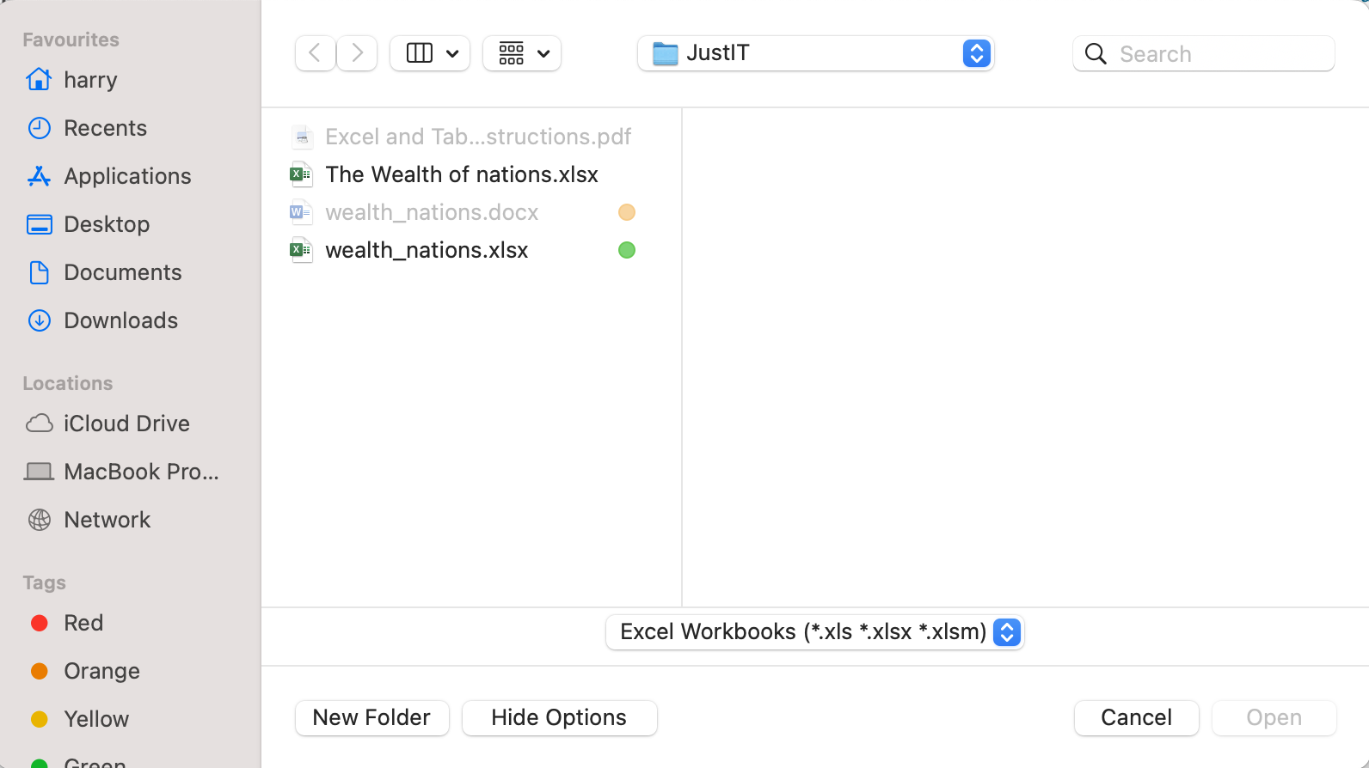Open Excel file to connect the different sheets
* To custom the charts, I selected format clicking inside the chart to access the different configurations.

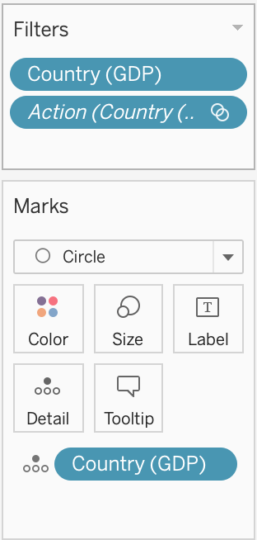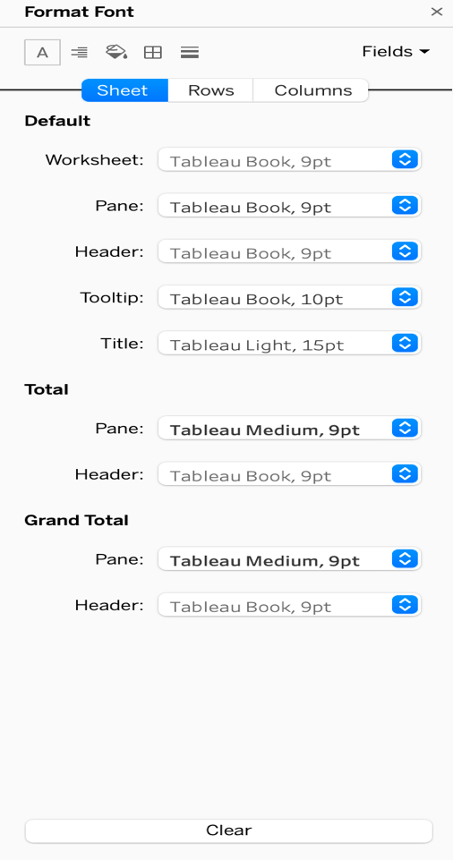

* On the map, I added the different fields of the countries and I colorized the map using countries.

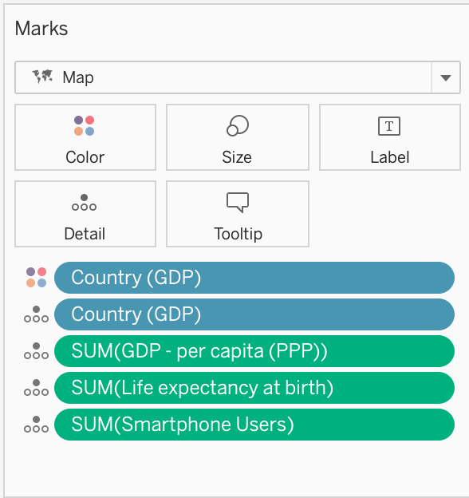

* On the bar chart, I added each variable to the row field and using countries in the x axis.

In this case, also use the different variables to fill the label of each column with accurate data.

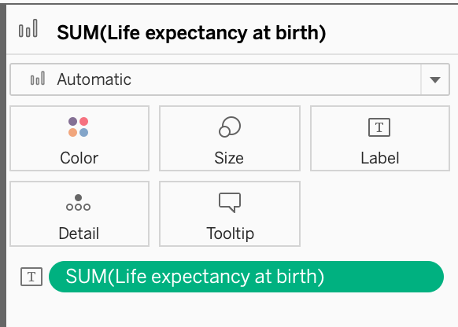

* On the scatter charts, I had to change the data to dimension data to get this kind of chart.

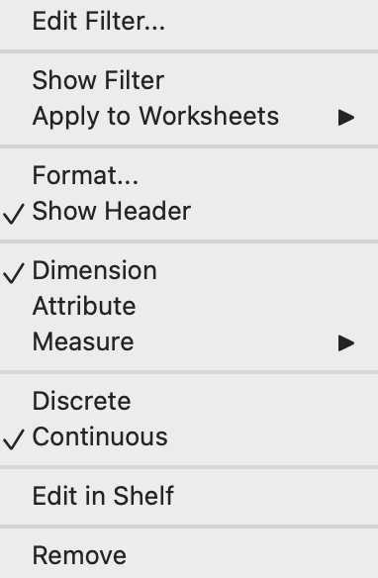

* On the dashboard, I use a container to join the different box charts.

**Reflective Account**

What went well and positives of the project:

- I got to know both tools (Excel and Tableau) well, using them in an effective way, understanding pretty well how they complement each other and how they are different.

- With the assignment, I understood the importance of using graphs to express the meaning behind the data and why it is key to create a good visualization that the user can easily understand and use.

- One key lesson from the assignment was realising that the more you practice with the tools, the more you learn different tricks and possibilities. The wide variety of commands and settings make Excel and Tableau tools with endless possibilities that need continuous practice to remember and learn more and more.

- Another essential lesson from the assignment was how important it is to review the data, understanding in what conditions it is, how to clean it up and how to manipulate it to improve the visualisation of the data. In fact, a key point that I realised was to see how much the condition of the data can impact the quality of the graphs that are produced.

- An extremely useful tool I learned during the assignment was how to relate sheets and tables between them to find their common denominator. This has proved extremely useful to analyse the data in a more meaningful way.

Areas of improvement:

- An area for me to continue improving is the personalisation of the charts. I encountered a few issues with remembering where the commands were, and how to navigate the different menus to make the changes I needed to personalise the charts according to my taste. I understand that this can only be achieved by practicing more and more and continuous exploring of the different commands the software provides.

- It was eye-opening to realise how the settings can affect the publishing online of the results on Tableau. I had an issue with making my dashboard visible for other devices, and it took me a while to get the selection of output devices correctly.  So, it is key to have the settings clearly understood to avoid confusion and time wasting.

- I know that another area I need to continue improving is the terminology between different tools. As a new user, throughout the time I was doing the assignment I mixed up the terminology and the concepts between Excel and Tableau on several occasions, which could result in confusion if I don't work on it in the future.